Examining Truth: Teaching the New Nonfiction
Jason Griffith, Jason.J.Griffith@asu.edu
Arizona State University

Reading Activities
- “To (All) The Colleges That Rejected Me” by Suzy Lee Weiss, Wall-Street Journal Editorial https://www.wsj.com/articles/SB10001424127887324000704578390340064578654

- From Lopez, S. (2008). The Soloist: A Lost Dream, an unlikely friendship, and the redemptive power of music. New York: Berkley Books, pp. 61-64.
A modest renaissance is under way, with long-abandoned buildings coming to life, but much of the east side of downtown is still a job center by day and a shadowy memory by night. At Fourth and Main I hit the border of civilization. Pete’s Café is there, along with a few gentrified apartment buildings, the homes of artists and young urban pioneers. There’s a whiff or order and hope. But take one step north, south or east, and the deal is off. At Fourth and Los Angeles, a man lurks in a doorway with product for sale, and he’s got his antenna up to make me as a customer or cop. I haven’t shaved and I’m wearing jeans, sneakers and a ball cap, a getup I think might help me blend in, but in truth I stand out like a tourist in Amish Country. You can’t look at anyone here. It’s a giveaway. You light the crack pipe, hire the hooker or get out of Dodge. I’m fooling no one, and suspicious eyes track my every step. On the corner, a Dumpster reeks of rotten food and dead flesh. The daytime bustle of Toy District commerce disappears as darkness and indifference grow. The last drafts of sunbaked urine rise off of stained asphalt and concrete. All systems are down and the place smells of doom.
This is where Nathaniel lives, and I need to ask him why. It would be safer to spend his nights where he spends his days. I keep moving and see a prostitute young enough to still be in high school. She’s blond and petite, a little angel of a crack whore, swinging along between blow jobs and hits on the pipe.
“Hey baby,” calls a man in a cardboard box.
“How you doing tonight, honey?” she sings back.
The streets are trashed. Drunks are down and out, like fallen soldiers. Nathaniel has been telling me about a beating victim here, and I don’t know if he’s talking about the unsolved murder I heard about, a case so fresh the body’s still in the morgue. Should have seen the guy’s face, he said. “I don’t know why you beat a person like that.”
An unpaid debt. A psychotic blitz. A random blow. Out here, it could have been anything.
I make my way up Winston toward Main and feel as though I could be next. A guy is coming toward me with a purpose. I toss a glance over my shoulder to see if he’s got company for an ambush. Am I being too paranoid? I’d make an easy mark for a quick mugging. But there’s nothing behind me except my shadow. Still, my flesh rises as the man slides by like a shark. A dealer, I guess. Just checking me out and sending a signal that no browsing is allowed. If I’m not buying, it’s time to leave the store.
Back on Los Angeles Street, a San Fernando Valley ministry arrives with a van and a truck and sets up a sidewalk food line, the missionaries chattering in Spanish as they hand out plates of chicken and beans to a growing line of takers. The hungry dropouts dig in, cleaning bones to a shine and wiping their mouths with the backs of grimy hands. One stumbling Latino drunk begins blubbering after his meal and the missionaries gather around him as he kneels on the pavement. They reach for my hand and take me into the prayer circle. The group leader lays hands on the kneeling drunk, whose tears splatter the pavement, and they all begin to pray in Spanish.
This is the second largest city in the United States. I am three blocks from the Times Building, four blocks from City Hall, out of sight and beyond the collective consciousness. Nothing here exists. The brilliant night skyline, a profit-chart etching, reaches the stars. A woman in distress zigzags toward me. She looks like she might be sixty-five but as she gets closer she’s fifty-five, now forty-five, now in her thirties. A young face is cracked, sunburned and coked out. Her hands are filthy, her sweatpants stained in the seat. She circles, wobbles and stumbles to a pay phone and dials. Not two minutes later a siren cuts toward us in surround sound, the piercing wail bouncing off buildings as the four-man engine crew response to another call in the 911 drama that plays all night every night.
“It’s my heart,” the woman tells the rescue crew, and they load her up and shuttle her off to County-USC Medical Center as a firefighter/paramedic tells me it never stops. ODs. Beatings. Heart attacks. Bodies laid out in tents and behind Dumpsters. War veterans fallen from wheelchairs and into the fetid streets.
I walk up Winston but when I turn back I find myself isolated one more time with a man emerging from the shadows. He’s probably just another dealer looking for a sale, but the sound of the siren and the memory of Nathaniel’s story of a beating victim are too fresh, so I turn back and linger at the corner, where a bearded man of about sixty is setting down his sidewalk bedding. I ask if he’s familiar with the guy who lugs a shopping cart to this street and sleeps here every night.
“Lots of shopping carts out here,” he says.
I’m trying to talk him into a bed at Lamp, I tell the guy.
“If he’s got a cart,” he tells me, sharing a bit of street wisdom that seems obvious now that he mentions it, “that’s not the type that’s ready to come in.”
And why isn’t this guy ready to come in? I wonder. He’s got no cart. Maybe he’s one of the many who can’t tolerate the rules and close quarters of the shelters. That’s part of what Nathaniel is avoiding, too, I’m sure. But, I’m not trying to get him to a shelter, where hundreds of people sack out on cots. If he gets housing through Lamp, it’ll be his own place. And if all he wants to do is play music, wouldn’t it be easier if he had a safe and quiet home to call his own?
Finally, around nine o’clock, I see the familiar image at the top of Winston, a shadowy figure with a cart in tow. Nathaniel has arrived. He stops under and apartment building with the sonic blast of a rock band pouring through the windows.

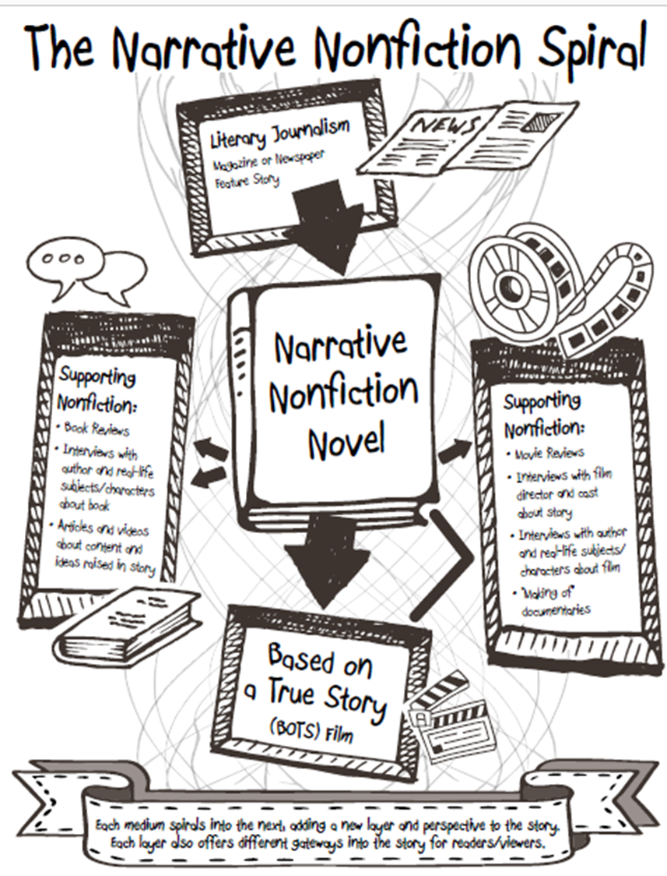

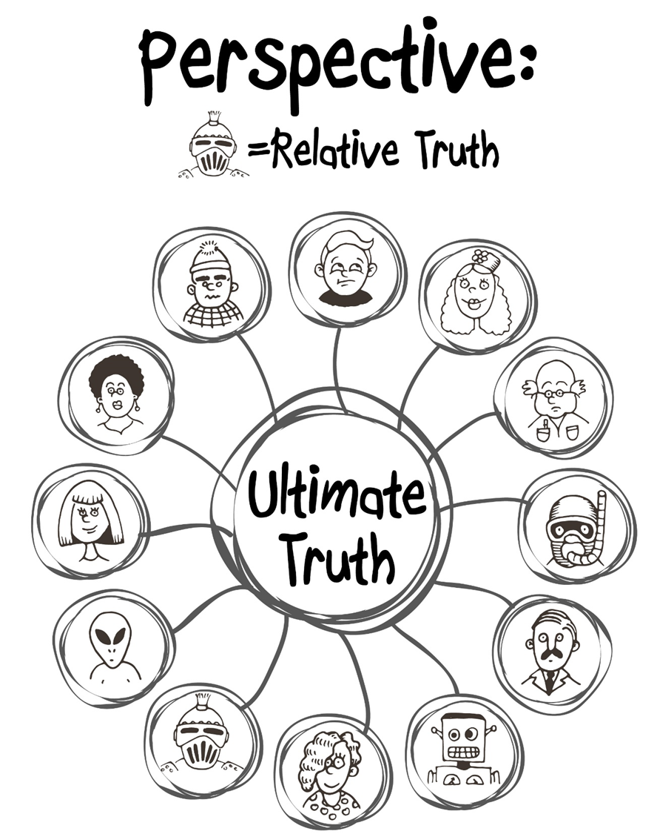

Narrative Nonfiction Resources

Creative Writing Journals Featuring Creative Nonfiction
- Creative Nonfiction Magazine: True Stories, well told. https://www.creativenonfiction.org/
- The Sun: Personal. Provacative. Political. Provocative. Ad-free. http://thesunmagazine.org/
- Hippocampus Magazine: Memorable creative nonfiction.
http://www.hippocampusmagazine.com/
- Brevity: A Journal of Concise Literary Nonfiction. http://brevitymag.com/
- Riverteeth: A Journal of Nonfiction Narrative. http://www.riverteethjournal.com/
- Fourth Genre: Explorations in Nonfiction. http://msupress.org/journals/fg/
- 1966: A Journal of Creative Nonfiction. http://1966journal.org/
Books on the Genre/Craft
- You Can’t Make This Stuff Up: The Complete Guide to Writing Creative Nonfiction from Memoir to Literary Journalism and Everything in Between by Lee Gutkind
- Minds Made for Stories: How We Really Read and Write Informational and Persuasive Texts by Tom Newkirk
- To Show and the Tell: The Craft of Literary Nonfiction by Phillip Lopate
- Writing for Story: Craft Secrets of Dramatic Nonfiction by a Two-Time Pulitzer Prize Winner by Jon Franklin
- Tell it Slant: Creating, Refining, and Publishing Creative Nonfiction by Brenda Miller and Suzanne Paola
- Crafting the Personal Essay: A Guide for Writing and Publishing Creative Nonfiction by Dinty Moore
Personal Essay Anthologies
- The Best American Essays (Published Yearly), Robert Atwan Series Editor
    - Guest Editors have included Ariel Levy, Edwidge Danticat, Cheryl Strayed, John Jeremiah Sullivan, David Brooks, David Foster Wallace, and others.
- The Impossible Will Take a Little While: A Citizens Guide to Hope in a Time of Fear, Paul Rogat Loeb (Ed)
    - Contributors include: Diane Ackerman, Sherman Alexie, Maya Angelou, Marian Wright Edelman, Jonathan Kozol, Nelson Mandela, Cornell West, and others.
- 40 Model Essays: A Portable Anthology, Jane E. Aaron & Ellen Kuhl Repetto (Eds)
- 50 Essays: A Portable Anthology, Samuel Cohen (Ed).
Standout Narrative Nonfiction Podcasts
  - The Moth Radio Hours: http://themoth.org/
  - This American Life: http://www.thisamericanlife.org/
  - Serial: http://serialpodcast.org/
  - Radiolab: http://www.radiolab.org/
  - Snap Judgment: http://snapjudgment.org/
Student Writing Opportunities
  - Scholastic Art & Writing Awards, Personal Essay & Memoir Category: http://www.artandwriting.org/
  - The Norman Mailer High School Nonfiction Writing Award: http://www.ncte.org/awards/nmwa
Teen Ink? One Teen Story? Narrative Magazine HS Essay Contest, www.stageoflife.com

