Examining Truth: Reading and Writing the New Nonfiction
Jason Griffith, Jason.J.Griffith@asu.edu
Arizona State University

Reading Activities
- Weiss, S.L. (2013, Mar 30). To (all) the colleges that rejected me. Wall Street Journal Retrieved from http://login.ezproxy1.lib.asu.edu/login?url=https://search-proquest-com.ezproxy1.lib.asu.edu/docview/1321556187?accountid=4485
Like me, millions of high-school seniors with sour grapes are asking themselves this week how they failed to get into the colleges of their dreams. It's simple: For years, they -- we -- were lied to.
Colleges tell you, "Just be yourself." That is great advice, as long as yourself has nine extracurriculars, six leadership positions, three varsity sports, killer SAT scores and two moms. Then by all means, be yourself! If you work at a local pizza shop and are the slowest person on the cross-country team, consider taking your business elsewhere.
What could I have done differently over the past years?
For starters, had I known two years ago what I know now, I would have gladly worn a headdress to school. Show me to any closet, and I would've happily come out of it. "Diversity!" I offer about as much diversity as a saltine cracker. If it were up to me, I would've been any of the diversities: Navajo, Pacific Islander, anything. Sen. Elizabeth Warren, I salute you and your 1/32 Cherokee heritage.
I also probably should have started a fake charity. Providing veterinary services for homeless people's pets. Collecting donations for the underprivileged chimpanzees of the Congo. Raising awareness for Chapped-Lips-in-the-Winter Syndrome. Fun-runs, dance-a-thons, bake sales -- as long as you're using someone else's misfortunes to try to propel yourself into the Ivy League, you're golden.
Having a tiger mom helps, too. As the youngest of four daughters, I noticed long ago that my parents gave up on parenting me. It has been great in certain ways: Instead of "Be home by 11," it's "Don't wake us up when you come through the door, we're trying to sleep." But my parents also left me with a dearth of hobbies that make admissions committees salivate. I've never sat down at a piano, never plucked a violin. Karate lasted about a week and the swim team didn't last past the first lap. Why couldn't Amy Chua have adopted me as one of her cubs?
Then there was summer camp. I should've done what I knew was best -- go to Africa, scoop up some suffering child, take a few pictures, and write my essays about how spending that afternoon with Kinto changed my life. Because everyone knows that if you don't have anything difficult going on in your own life, you should just hop on a plane so you're able to talk about what other people have to deal with.

Or at least hop to an internship. Get a precocious-sounding title to put on your resume. "Assistant Director of Mail Services." "Chairwoman of Coffee Logistics." I could have been a gopher in the office of someone I was related to. Work experience!
To those kids who by age 14 got their doctorate, cured a disease, or discovered a guilt-free brownie recipe: My parents make me watch your "60 Minutes" segments, and they've clipped your newspaper articles for me to read before bed. You make us mere mortals look bad. (Also, I am desperately jealous and willing to pay a lot to learn your secrets.)
To those claiming that I am bitter -- you bet I am! An underachieving selfish teenager making excuses for her own failures? That too! To those of you disgusted by this, shocked that I take for granted the wonderful gifts I have been afforded, I say shhhh -- "The Real Housewives" is on.

- From Lopez, S. (2008). The Soloist: A Lost Dream, an unlikely friendship, and the redemptive power of music. New York: Berkley Books, pp. 61-64.
A modest renaissance is under way, with long-abandoned buildings coming to life, but much of the east side of downtown is still a job center by day and a shadowy memory by night. At Fourth and Main I hit the border of civilization. Pete’s Café is there, along with a few gentrified apartment buildings, the homes of artists and young urban pioneers. There’s a whiff or order and hope. But take one step north, south or east, and the deal is off. At Fourth and Los Angeles, a man lurks in a doorway with product for sale, and he’s got his antenna up to make me as a customer or cop. I haven’t shaved and I’m wearing jeans, sneakers and a ball cap, a getup I think might help me blend in, but in truth I stand out like a tourist in Amish Country. You can’t look at anyone here. It’s a giveaway. You light the crack pipe, hire the hooker or get out of Dodge. I’m fooling no one, and suspicious eyes track my every step. On the corner, a Dumpster reeks of rotten food and dead flesh. The daytime bustle of Toy District commerce disappears as darkness and indifference grow. The last drafts of sunbaked urine rise off of stained asphalt and concrete. All systems are down and the place smells of doom.
This is where Nathaniel lives, and I need to ask him why. It would be safer to spend his nights where he spends his days. I keep moving and see a prostitute young enough to still be in high school. She’s blond and petite, a little angel of a crack whore, swinging along between blow jobs and hits on the pipe.
“Hey baby,” calls a man in a cardboard box.
“How you doing tonight, honey?” she sings back.
The streets are trashed. Drunks are down and out, like fallen soldiers. Nathaniel has been telling me about a beating victim here, and I don’t know if he’s talking about the unsolved murder I heard about, a case so fresh the body’s still in the morgue. Should have seen the guy’s face, he said. “I don’t know why you beat a person like that.”
An unpaid debt. A psychotic blitz. A random blow. Out here, it could have been anything.
I make my way up Winston toward Main and feel as though I could be next. A guy is coming toward me with a purpose. I toss a glance over my shoulder to see if he’s got company for an ambush. Am I being too paranoid? I’d make an easy mark for a quick mugging. But there’s nothing behind me except my shadow. Still, my flesh rises as the man slides by like a shark. A dealer, I guess. Just checking me out and sending a signal that no browsing is allowed. If I’m not buying, it’s time to leave the store.
Back on Los Angeles Street, a San Fernando Valley ministry arrives with a van and a truck and sets up a sidewalk food line, the missionaries chattering in Spanish as they hand out plates of chicken and beans to a growing line of takers. The hungry dropouts dig in, cleaning bones to a shine and wiping their mouths with the backs of grimy hands. One stumbling Latino drunk begins blubbering after his meal and the missionaries gather around him as he kneels on the pavement. They reach for my hand and take me into the prayer circle. The group leader lays hands on the kneeling drunk, whose tears splatter the pavement, and they all begin to pray in Spanish.
This is the second largest city in the United States. I am three blocks from the Times Building, four blocks from City Hall, out of sight and beyond the collective consciousness. Nothing here exists. The brilliant night skyline, a profit-chart etching, reaches the stars. A woman in distress zigzags toward me. She looks like she might be sixty-five but as she gets closer she’s fifty-five, now forty-five, now in her thirties. A young face is cracked, sunburned and coked out. Her hands are filthy, her sweatpants stained in the seat. She circles, wobbles and stumbles to a pay phone and dials. Not two minutes later a siren cuts toward us in surround sound, the piercing wail bouncing off buildings as the four-man engine crew response to another call in the 911 drama that plays all night every night.
“It’s my heart,” the woman tells the rescue crew, and they load her up and shuttle her off to County-USC Medical Center as a firefighter/paramedic tells me it never stops. ODs. Beatings. Heart attacks. Bodies laid out in tents and behind Dumpsters. War veterans fallen from wheelchairs and into the fetid streets.
I walk up Winston but when I turn back I find myself isolated one more time with a man emerging from the shadows. He’s probably just another dealer looking for a sale, but the sound of the siren and the memory of Nathaniel’s story of a beating victim are too fresh, so I turn back and linger at the corner, where a bearded man of about sixty is setting down his sidewalk bedding. I ask if he’s familiar with the guy who lugs a shopping cart to this street and sleeps here every night.
“Lots of shopping carts out here,” he says.
I’m trying to talk him into a bed at Lamp, I tell the guy.
“If he’s got a cart,” he tells me, sharing a bit of street wisdom that seems obvious now that he mentions it, “that’s not the type that’s ready to come in.”
And why isn’t this guy ready to come in? I wonder. He’s got no cart. Maybe he’s one of the many who can’t tolerate the rules and close quarters of the shelters. That’s part of what Nathaniel is avoiding, too, I’m sure. But, I’m not trying to get him to a shelter, where hundreds of people sack out on cots. If he gets housing through Lamp, it’ll be his own place. And if all he wants to do is play music, wouldn’t it be easier if he had a safe and quiet home to call his own?
Finally, around nine o’clock, I see the familiar image at the top of Winston, a shadowy figure with a cart in tow. Nathaniel has arrived. He stops under and apartment building with the sonic blast of a rock band pouring through the windows.

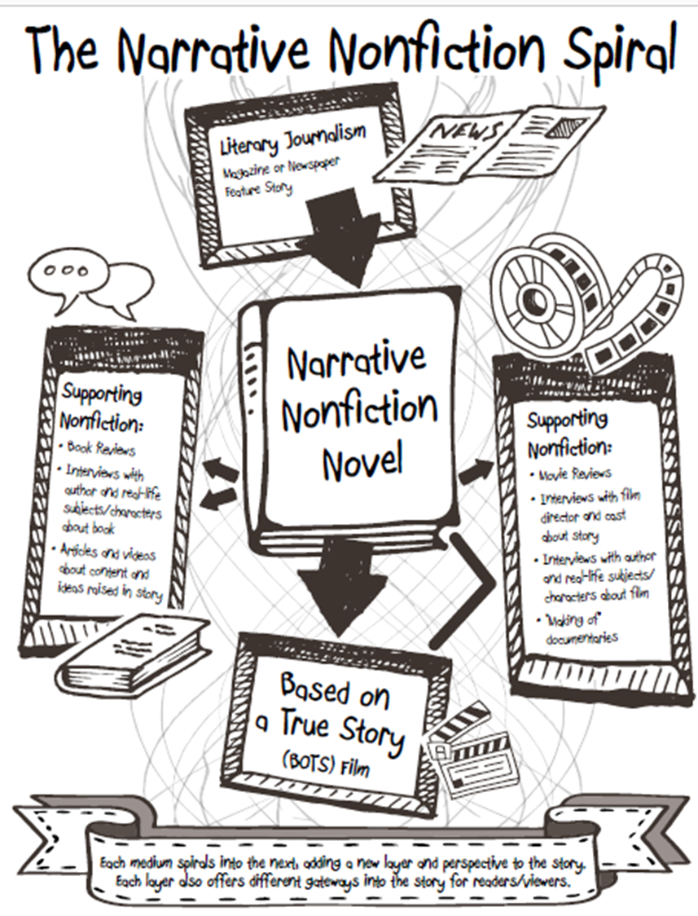

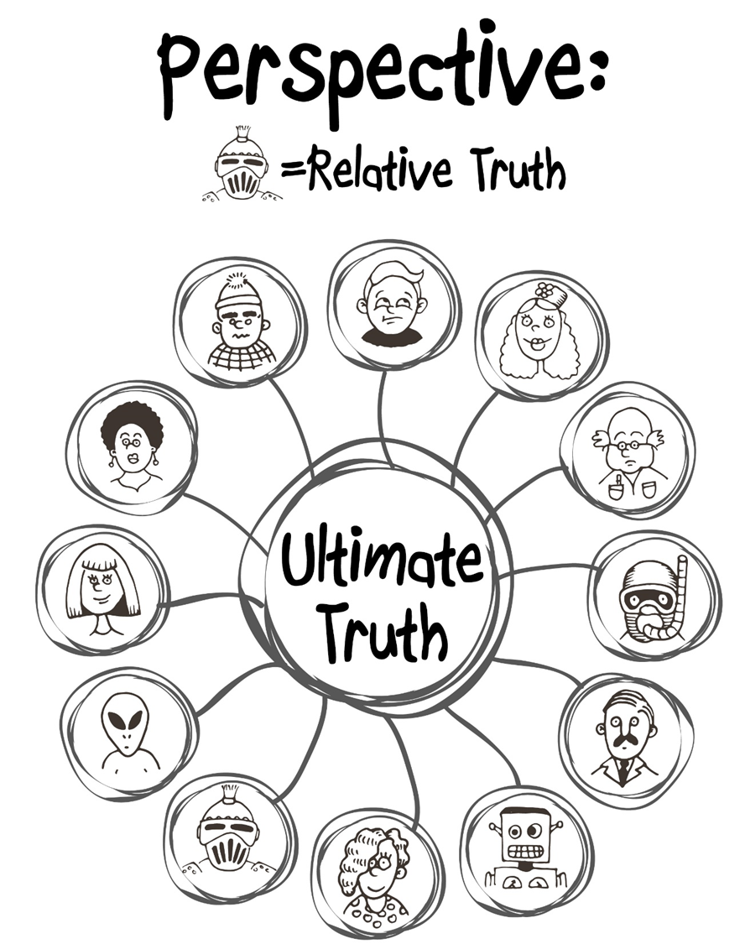

Appendix B: Narrative Nonfiction Resources

Creative Writing Journals Featuring Creative Nonfiction
- Creative Nonfiction Magazine: True Stories, well told. https://www.creativenonfiction.org/
- The Sun: Personal. Political. Provocative. Ad-free. http://thesunmagazine.org/
- Hippocampus Magazine: Memorable creative nonfiction.
http://www.hippocampusmagazine.com/
- Brevity: A Journal of Concise Literary Nonfiction. http://brevitymag.com/
- Riverteeth: A Journal of Nonfiction Narrative. http://www.riverteethjournal.com/
- Fourth Genre: Explorations in Nonfiction. http://msupress.org/journals/fg/
- 1966: A Journal of Creative Nonfiction. http://1966journal.org/
Books on the Genre/Craft
- You Can’t Make This Stuff Up: The Complete Guide to Writing Creative Nonfiction from Memoir to Literary Journalism and Everything in Between by Lee Gutkind
- Minds Made for Stories: How We Really Read and Write Informational and Persuasive Texts by Tom Newkirk
- To Show and to Tell: The Craft of Literary Nonfiction by Phillip Lopate
- Writing for Story: Craft Secrets of Dramatic Nonfiction by a Two-Time Pulitzer Prize Winner by Jon Franklin
- Tell it Slant: Creating, Refining, and Publishing Creative Nonfiction by Brenda Miller and Suzanne Paola
- Crafting the Personal Essay: A Guide for Writing and Publishing Creative Nonfiction by Dinty Moore
Personal Essay Anthologies
- The Best Teen Writing (Published Yearly), Includes national gold-medal winning works from the Scholastic
Art & Writing Awards. More award-winning student personal essay/memoir can be found online at www.artandwriting.org
- The Best American Essays (Published Yearly), Robert Atwan Series Editor
    - Guest Editors have included Ariel Levy, Edwidge Danticat, Cheryl Strayed, John Jeremiah Sullivan, David Brooks, David Foster Wallace, and others.
    - Also check out Best American Sports Writing, Best American Travel Writing, Best American Non-required Reading, and others in the broader series for more specific sub-genres of narrative nonfiction.
- True Stories, Well Told: From the First 20 Years of Creative Nonfiction Magazine, Lee Gutkind & Hattie
Fletcher (Eds)
- This I Believe Volumes I and II, Jay Allison & Dan Gediman (Eds); archive of This I Believe essays (including
those featured on NPR) can be found at http://thisibelieve.org
- The Impossible Will Take a Little While: A Citizens Guide to Hope in a Time of Fear, Paul Rogat Loeb (Ed)
    - Contributors include: Diane Ackerman, Sherman Alexie, Maya Angelou, Marian Wright Edelman, Jonathan Kozol, Nelson Mandela, Cornell West, and others.
- 40 Model Essays: A Portable Anthology, Jane E. Aaron & Ellen Kuhl Repetto (Eds)
- 50 Essays: A Portable Anthology, Samuel Cohen (Ed).
Standout Narrative Nonfiction Podcasts
  - The Moth Radio Hour: http://themoth.org/
  - This American Life: http://www.thisamericanlife.org/
  - Serial: http://serialpodcast.org/
  - Radiolab: http://www.radiolab.org/
  - Snap Judgment: http://snapjudgment.org/
Student Writing Opportunities
  - Scholastic Art & Writing Awards, Personal Essay & Memoir Category:
http://www.artandwriting.org/
  - The Norman Mailer High School Nonfiction Writing Award:
http://www.ncte.org/awards/nmwa
  - New Pages’ Young Authors’ Guide: A comprehensive listing of student writing publications and resources: http://www.newpages.com/npguides/young_authors_guide.htm
  - Adroit Journal: Literary magazine run by college and high school students:
http://adroit.co.nr/
  - Narrative Magazine High School Essay Contest:
www.narrativemagazine.com
  - Stage of Life: Blogging, Writing Contests, and Life for Teens:
www.stageoflife.com
  - Teen Ink: Magazine, website, and books written by teens since 1989. Nonfiction category:
www.teenink.com/nonfiction/

