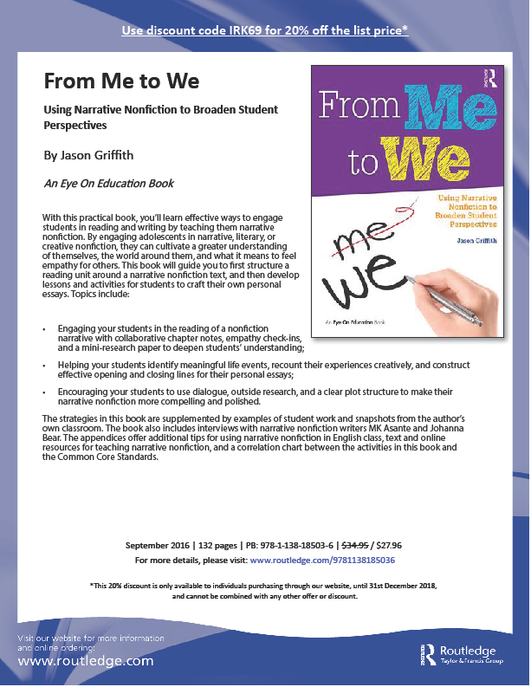
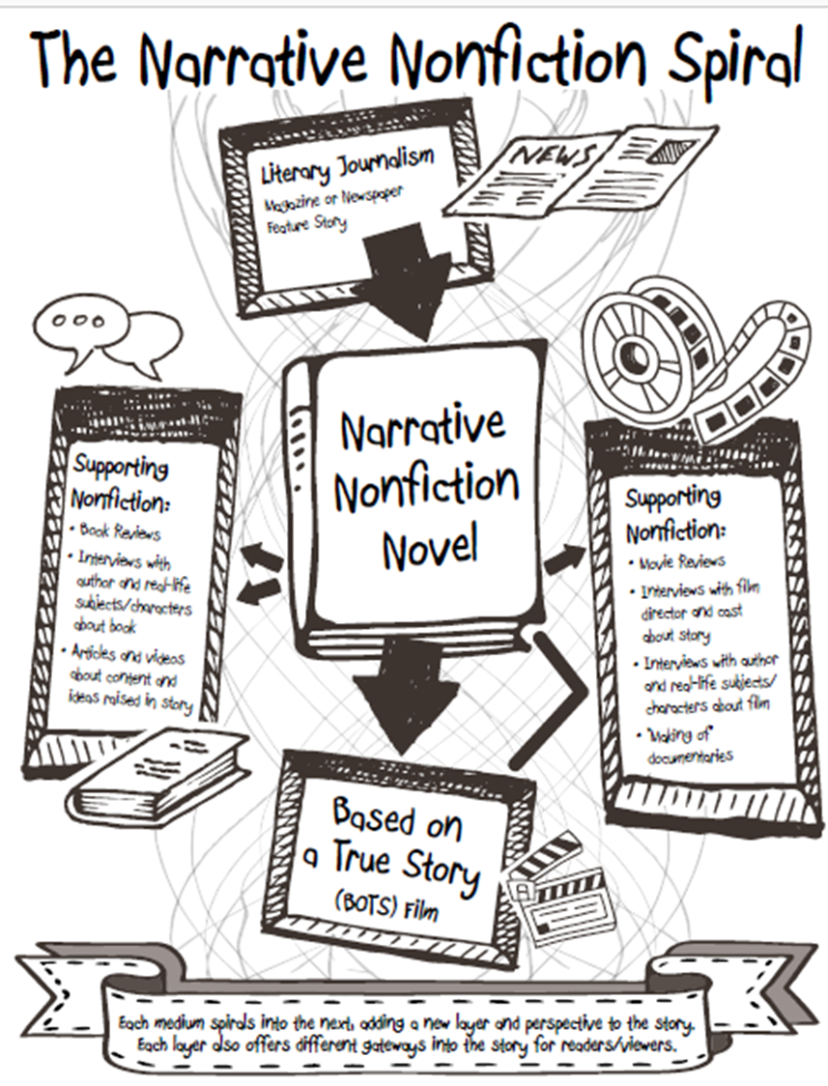

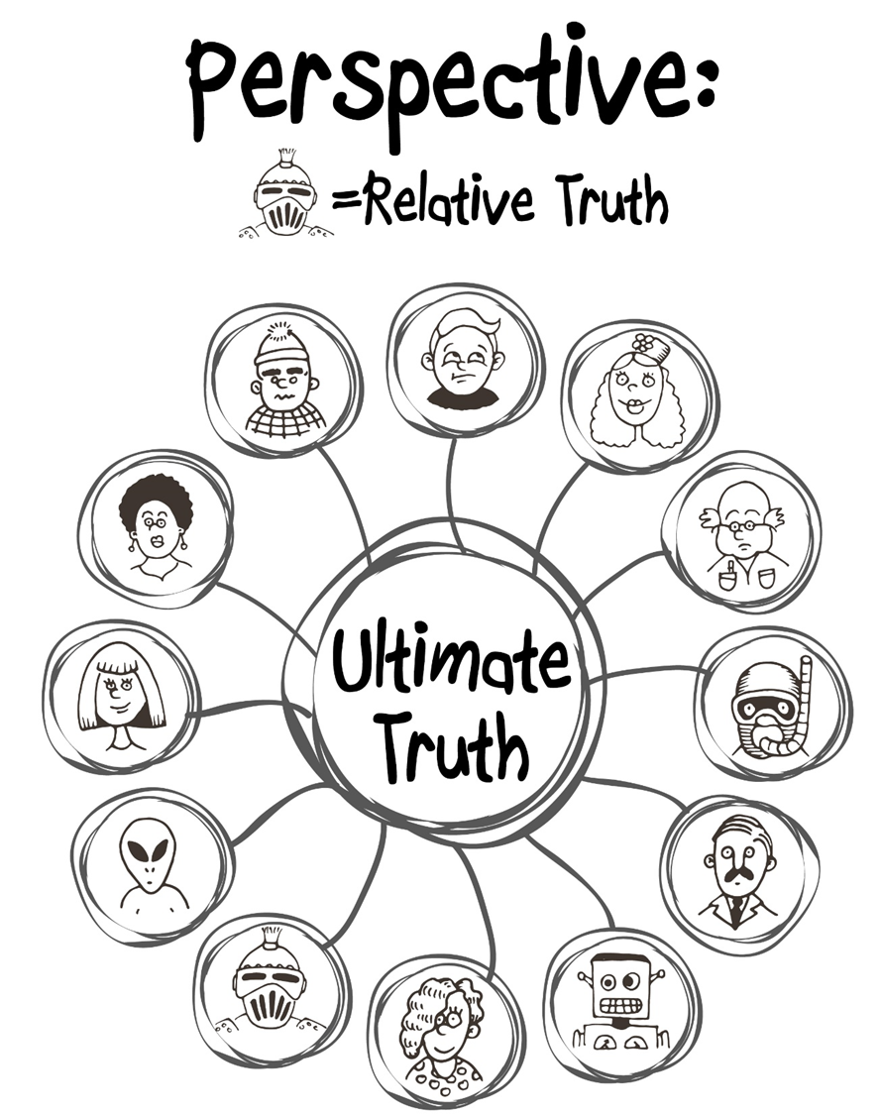

Appendix B: Narrative Nonfiction Resources

Creative Writing Journals Featuring Creative Nonfiction
- Creative Nonfiction Magazine: True Stories, well told. https://www.creativenonfiction.org/
- The Sun: Personal. Political. Provocative. Ad-free. http://thesunmagazine.org/
- Hippocampus Magazine: Memorable creative nonfiction.
http://www.hippocampusmagazine.com/
- Brevity: A Journal of Concise Literary Nonfiction. http://brevitymag.com/
- Riverteeth: A Journal of Nonfiction Narrative. http://www.riverteethjournal.com/
- Fourth Genre: Explorations in Nonfiction. http://msupress.org/journals/fg/
- 1966: A Journal of Creative Nonfiction. http://1966journal.org/
Books on the Genre/Craft
- You Can’t Make This Stuff Up: The Complete Guide to Writing Creative Nonfiction from Memoir to Literary Journalism and Everything in Between by Lee Gutkind
- Minds Made for Stories: How We Really Read and Write Informational and Persuasive Texts by Tom Newkirk
- To Show and to Tell: The Craft of Literary Nonfiction by Phillip Lopate
- Writing for Story: Craft Secrets of Dramatic Nonfiction by a Two-Time Pulitzer Prize Winner by Jon Franklin
- Tell it Slant: Creating, Refining, and Publishing Creative Nonfiction by Brenda Miller and Suzanne Paola
- Crafting the Personal Essay: A Guide for Writing and Publishing Creative Nonfiction by Dinty Moore
Personal Essay Anthologies
- The Best Teen Writing (Published Yearly), Includes national gold-medal winning works from the Scholastic
Art & Writing Awards. More award-winning student personal essay/memoir can be found online at www.artandwriting.org
- The Best American Essays (Published Yearly), Robert Atwan Series Editor
    - Guest Editors have included Ariel Levy, Edwidge Danticat, Cheryl Strayed, John Jeremiah Sullivan, David Brooks, David Foster Wallace, and others.
    - Also check out Best American Sports Writing, Best American Travel Writing, Best American Non-required Reading, and others in the broader series for more specific sub-genres of narrative nonfiction.
- True Stories, Well Told: From the First 20 Years of Creative Nonfiction Magazine, Lee Gutkind & Hattie
Fletcher (Eds)
- This I Believe Volumes I and II, Jay Allison & Dan Gediman (Eds); archive of This I Believe essays (including
those featured on NPR) can be found at http://thisibelieve.org
- The Impossible Will Take a Little While: A Citizens Guide to Hope in a Time of Fear, Paul Rogat Loeb (Ed)
    - Contributors include: Diane Ackerman, Sherman Alexie, Maya Angelou, Marian Wright Edelman, Jonathan Kozol, Nelson Mandela, Cornell West, and others.
- 40 Model Essays: A Portable Anthology, Jane E. Aaron & Ellen Kuhl Repetto (Eds)
- 50 Essays: A Portable Anthology, Samuel Cohen (Ed).
Standout Narrative Nonfiction Podcasts
  - The Moth Radio Hour: http://themoth.org/
  - This American Life: http://www.thisamericanlife.org/
  - Serial: http://serialpodcast.org/
  - Radiolab: http://www.radiolab.org/
  - Snap Judgment: http://snapjudgment.org/
Student Writing Opportunities
  - Scholastic Art & Writing Awards, Personal Essay & Memoir Category:
http://www.artandwriting.org/
  - The Norman Mailer High School Nonfiction Writing Award:
http://www.ncte.org/awards/nmwa
  - New Pages’ Young Authors’ Guide: A comprehensive listing of student writing publications and resources: http://www.newpages.com/npguides/young_authors_guide.htm
  - Adroit Journal: Literary magazine run by college and high school students:
http://adroit.co.nr/
  - Narrative Magazine High School Essay Contest:
www.narrativemagazine.com
  - Stage of Life: Blogging, Writing Contests, and Life for Teens:
www.stageoflife.com
  - Teen Ink: Magazine, website, and books written by teens since 1989. Nonfiction category:
www.teenink.com/nonfiction/

